- On the main RFMS screen click Products: 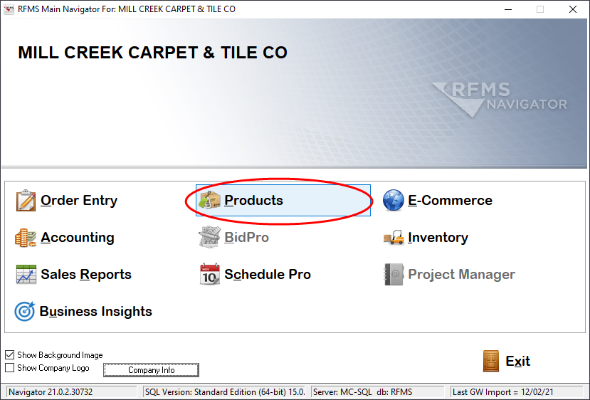

- Click File > Rolls or File > Items:
(Rolls for carpet, Items for Hard Surface & Carpet Tile)
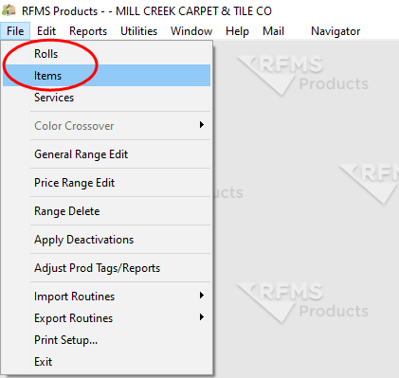

- Select the products to print tags/labels for:
  - Option 1 - To get a list of products by supplier
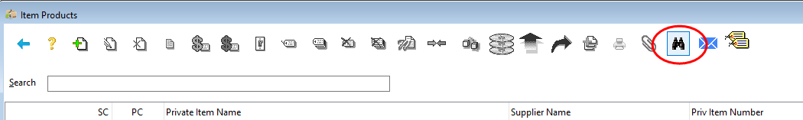
    - Click on the binoculars:

    - Click F8 to select the supplier:
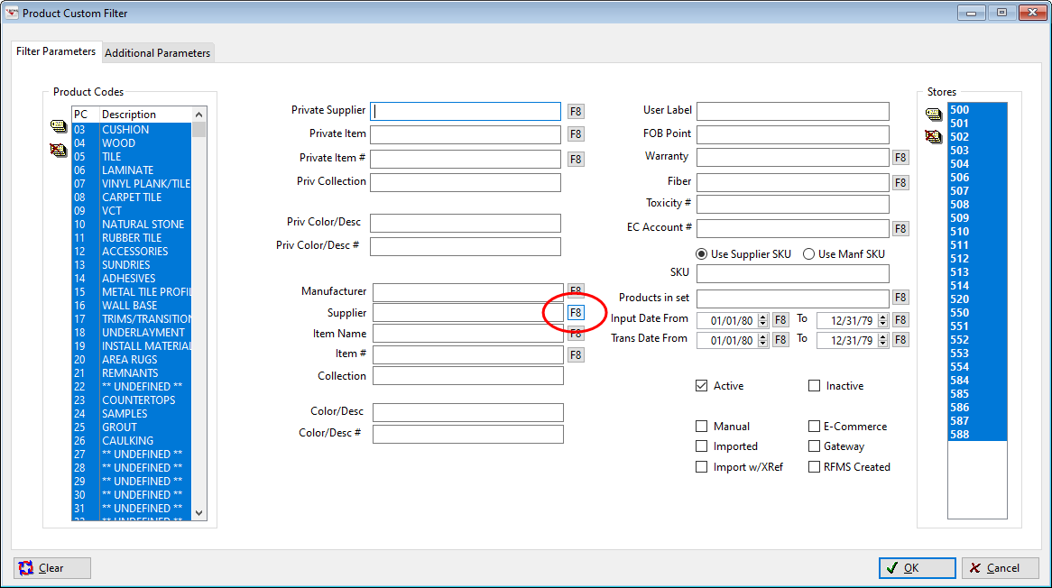
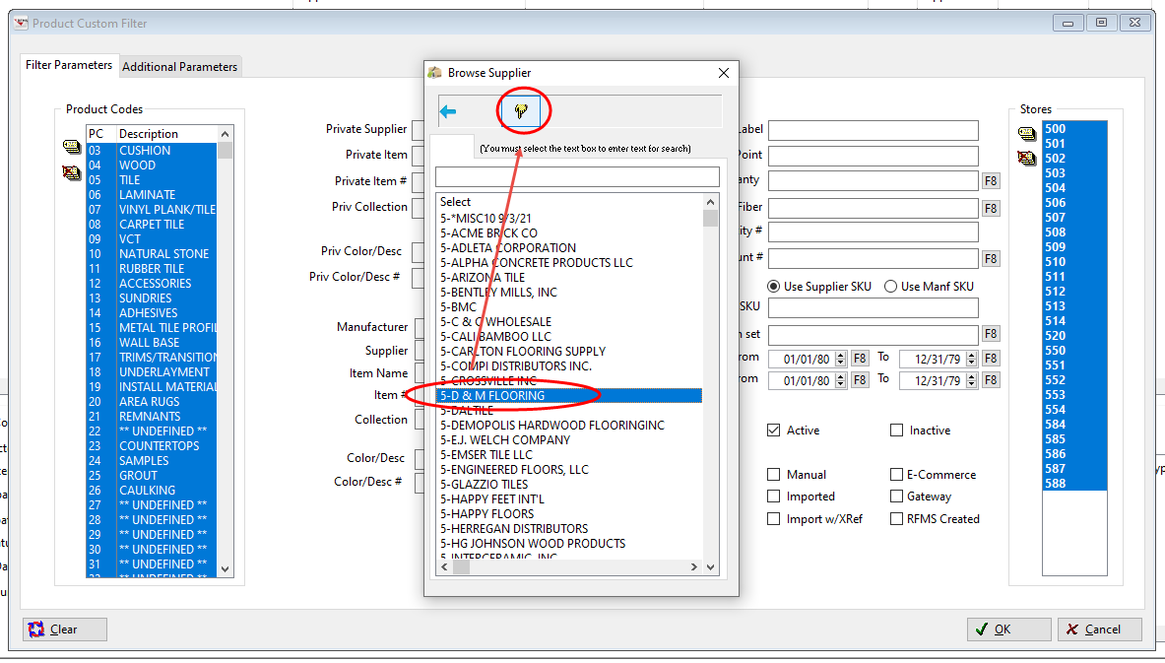
    - Select the supplier from the list and click the hand icon to select:

    - Tag your product store - All Mill Creek products are in store 500. All Flooring America products are in store 514.

    - Optional: tag only specific product codes on left
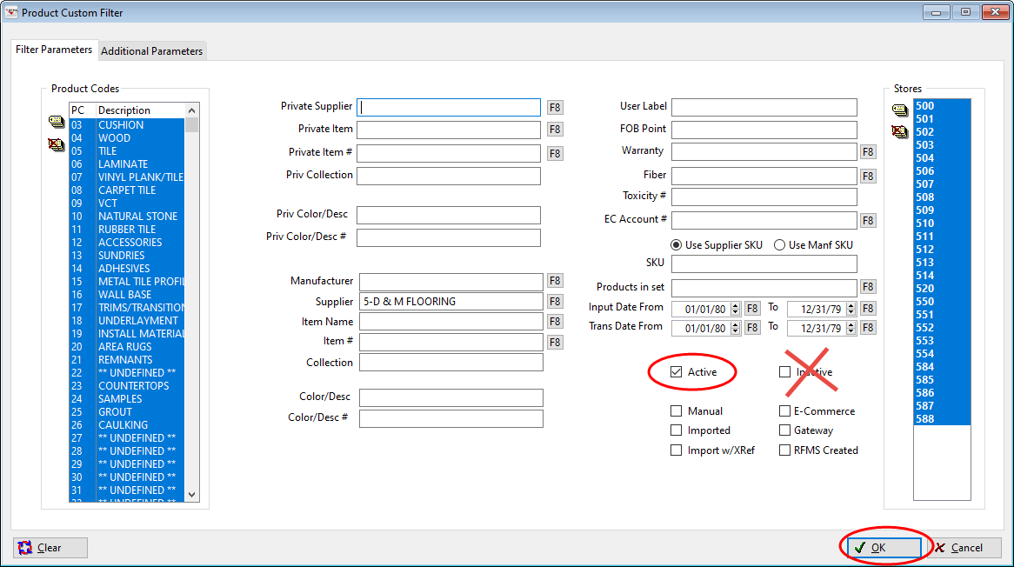
    - Make sure active is checked and inactive is not checked. Click OK:
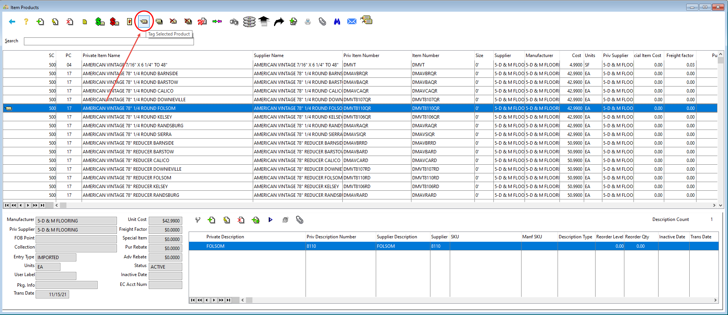
    - Tag the lines you want to print:

  - Option 2 – To print ‘one offs’
    - Enter the style name in the search field
    - Tag the product
    - Repeat until you have found and tagged all products

**If there are duplicates or you have questions about which SKU is correct contact Sharon L or Anita W**

- After you have all lines tagged click the printer icon: 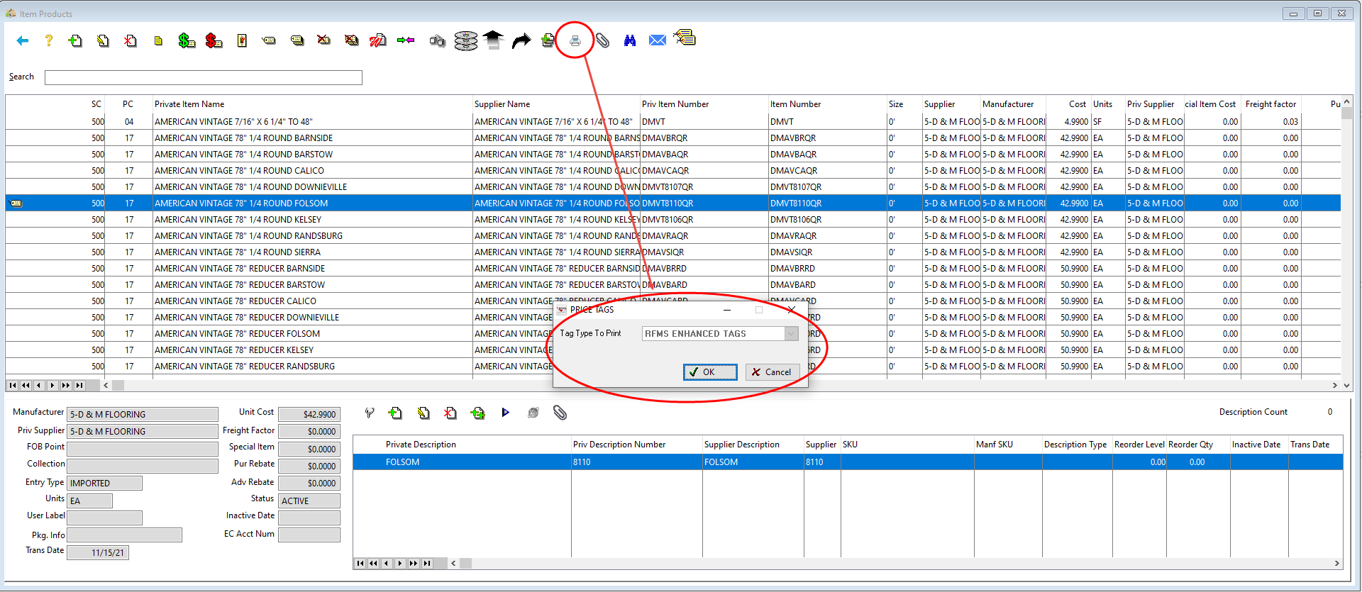

- Click Barcode Tag, Branch 500 (Remember: This is for products not inventory) and click OK: 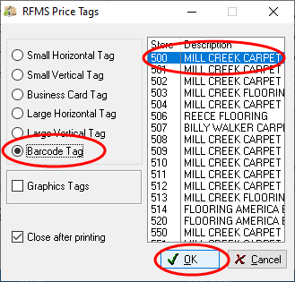

- Select No Price, Style/Color and click OK:
If you put a checkmark in ‘print colors’ it will print one tag for every color

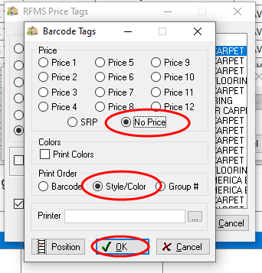
- Make sure you say Yes, you do want to UN-TAG all products.

